# Vertical full colour positive

**YEAR: 9**

**SUBJECT: SCIENCE**

**EXAM: Ecosystems, Heat and Electricity & Chemical Reactions**

**TIME: 5 mins reading + 55 mins working time**

**QUESTIONS:**

**Part A: Multiple Choice Questions (20 marks)**

**Part B: Short Answer Questions (50 marks)**

**TOTAL MARKS: 70 marks**

**DO NOT WRITE ON OR MARK THIS PAPER**

**SECTION ONE: Multiple Choice Questions (1 mark each)**

**Answer this section on the separate multiple – choice answer sheet**

1. The law of conservation of mass explains why, in a chemical reaction:
   1. energy cannot be created nor destroyed, only transformed or transferred.
   2. the total mass of reactants equals the total mass of products.
   3. new atoms are created from the reactant atoms.
   4. when rearranging atoms to form products, the mass changes significantly.
2. A chemical equation shows:
3. the chemical formulas of the reactants and products.
4. the names of the reactants and the products in words.
5. all the atoms in the compounds of the reactants, but not the products.
6. all the atoms involved in the reaction and how they rearrange into the products.
7. Copper reacts with sulfur dioxide to form copper sulfide and oxygen gas. The reactants for this reaction are:
8. copper
9. copper and sulfur dioxide
10. copper sulfide and oxygen gas
11. copper, sulphur dioxide, copper sulfide and oxygen gas
12. When petrol explodes, it releases energy in the form of heat and light. This reaction is an example of:
13. an endothermic reaction
14. an exothermic reaction
15. a neutralisation reaction
16. an extrathermic reaction
17. Neutralisation reactions between acids and bases can be generalised by which one of the following word equations?
18. acid + base → hydrogen gas + salt + water
19. acid + base → water
20. acid + base → salt + water
21. acid + base → salt + carbon dioxide + water
22. Which of the following chemical equations is correctly balanced?
23. HCl + NaOH → NaCl + H2O
24. H2 + O2 → H2O
25. 2Na + H2O → 2NaOH + H2
26. CaCl2 + PbCO3 → 2PbCl2 + CaCO3
27. Photosynthesis and aerobic respiration might appear to be opposite processes but they differ in many ways. Four differences are listed below. One is WRONG. Which is it?
28. Each proceeds via different steps.
29. Photosynthesis occurs in all cells of all living things while aerobic respiration

only occurs in the chloroplasts in the cells of green plants.

1. Photosynthesis happens only during the day while aerobic respiration

happens continuously.

1. The enzymes in photosynthesis speed up reactions while the enzymes in

aerobic respiration slow them down.

1. Where organisms live together and both benefit from the relationship, the interaction is classified as:
2. mutualism
3. commensalism
4. competition
5. parasitism
6. Producers are vital in ecosystems because:
7. they recycle nutrients back into the soil
8. they don’t consume other living things
9. they make carbon dioxide and oxygen
10. they are the only organisms that can make food materials
11. Look at the food chain shown. Using the information in the food chain, determine which statement is NOT a correct inference.

clover → caterpillar → lizard → kookaburra

1. The lizard consumes the caterpillar.
2. The clover is the producer.
3. The kookaburra is dependent on the clover.
4. There would be a greater mass of kookaburras than lizards.
5. From the following lists, choose the one that only contains physical (abiotic) factors.
6. rainfall, sunlight, competition, soil nutrients
7. temperature, wind speed, predation, humidity
8. soil moisture, sunlight, air temperature, soil texture
9. pollination, parasitism, humidity, soil humus content
10. A community consists of:
11. A group of the same species living in the same place at the same time
12. A group of living organisms together with their non-living factors
13. all the living organisms in an ecosystem
14. different populations living in the same place at the same time
15. Your hand feels cold as an ice-block melts on it. Identify the correct explanation for this process. Heat has transferred from:
16. the ice-block into your hand by conduction.
17. your hand to the ice-block by conduction.
18. the ice-block into your hand by radiation.
19. your hand to the ice-block by radiation.
20. To protect people from getting shocked, wires should be covered by
    1. insulators
    2. conductors
    3. metals
    4. Aluminium
21. Heat is a measure of
22. energy transfer from a hotter to a colder object
23. how hot or how cold something is
24. accurate readings of temperature
25. how quickly the particles are moving
26. Which of the following materials is an insulator?
27. nichrome
28. copper
29. aluminium
30. rubber
31. Heat passes through liquids chiefly by
32. conduction.
33. absorption.
34. convection
35. radiation.
36. Electric current is generated by the flow of
37. Protons
38. Electrons
39. Neutrons
40. Ions
41. The standard unit for electric current is
42. Volts
43. Ohms
44. Amperes
45. Ammeter
46. An electric circuit is constructed with a battery and two globes in parallel. If another globe is connected in parallel, what would happen to the brightness of the first two globes?
47. They would stay the same brightness.
48. They would get dimmer.
49. They would get brighter.
50. They would all ‘blow’.

**END OF MULTIPLE CHOICE SECTION**

Continue with short answer questions in answer booklet.



**SEMESTER TWO EXAM 2016**

**ANSWER BOOKLET**

**NAME:**

**FORM:** **DATE:**

|  |  |  |  |  |  |
| --- | --- | --- | --- | --- | --- |
| **Multiple**  **Choice** |  | **Short Answer** |  |  | **Total** |
|  |  |  |  |  |  |
| **20** |  | **50** |  |  | **70** |

**SECTION ONE:** Multiple choice answers

Cross (X) through the correct answer.

|  |  |  |  |  |
| --- | --- | --- | --- | --- |
| 1 | a | b | c | d |
| 2 | a | b | c | d |
| 3 | a | b | c | d |
| 4 | a | b | c | d |
| 5 | a | b | c | d |
| 6 | a | b | c | d |
| 7 | a | b | c | d |
| 8 | a | b | c | d |
| 9 | a | b | c | d |
| 10 | a | b | c | d |
| 11 | a | b | c | d |
| 12 | a | b | c | d |
| 13 | a | b | c | d |
| 14 | a | b | c | d |
| 15 | a | b | c | d |
| 16 | a | b | c | d |
| 17 | a | b | c | d |
| 18 | a | b | c | d |
| 19 | a | b | c | d |
| 20 | a | b | c | d |

**SECTION TWO: Short Answer (50 marks)**

Answer the questions in the spaces provided.

**Question 21 (4 marks)**

Ethane (C2H6) reacts with oxygen gas (O2) to form carbon dioxide (CO­2) and water vapour (H2O).

1. **Identify** the reactants of this reaction.

1. **Identify** the products of this reaction.

1. **Construct** a word equation for this reaction.

1. **Construct** an unbalanced formula equation for this reaction.

**Question 22 (5 marks)**

Magnesium burns in oxygen gas to form magnesium oxide. Its unbalanced formula equation is:

Mg + O2 → MgO

1. Use this equation to **identify** the chemical formula for magnesium oxide.

1. **Construct** a word equation describing this reaction.

1. **Identify** which element (Mg or O) is unbalanced in the above equation.

1. **Balance** the equation and re-write it below.

1. **Identify** the type of reaction that has taken place.

**Question 23 (4marks)**

**Balance** the following chemical equations:

1. 
2. 
3. 
4. 

**Question 24 (4 marks)**

The graph below shows the change in energy that occurs during a chemical reaction.

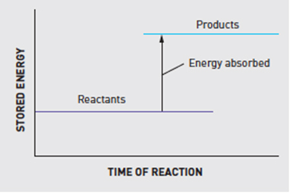

1. Is this an endothermic or an exothermic reaction? (1 mark)

1. Explain why you chose your answer for part a) above. (2 marks)

1. Where does the energy that is released in an exothermic reaction come from? (1 mark)

**Question 25 (4 marks)**

Match the names of the following acids and bases to their correct chemical formulas.

|  |  |
| --- | --- |
| ***Word Bank:* sodium hydroxide, hydrochloric acid, ammonia, sulfuric acid, HCl, NH3, H2SO4, NaOH** | |
| **NAME** | **CHEMICAL FORMULA** |
|  |  |
|  |  |
|  |  |
|  |  |

**Question 26**

Acids are commonly found around us. Bases can be described as the ‘chemical opposite’ of acids.

1. List the main properties of **acids** and **bases**. **(4 marks)**

|  |  |
| --- | --- |
| **ACIDS** | **BASES** |
|  |  |
|  |  |
|  |  |
|  |  |

1. What is the difference between a strong and a weak acid? (**2 marks)**

**Question 27 (5 marks)**

Use this graph to answer the following questions:

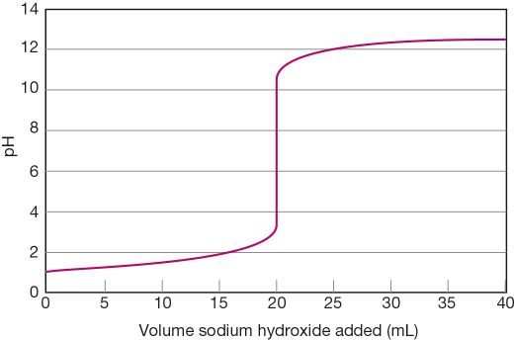Increasing volumes of sodium hydroxide (NaOH) were added to a solution of hydrochloric acid (HCl). As it was added, the pH changed according to the graph shown below.

1. State the pH of the solution at the start of the experiment.

1. Determine the volume of sodium hydroxide that is needed to be added to exactly neutralise the acid.

1. Determine the pH when 16 mL of sodium hydroxide was added.

1. Determine the total volume of sodium hydroxide added in the experiment.

1. At the end of the above experiment, what type of solution (acidic or basic) was formed?

**Question 28 (3 marks)**

The resulting colours of indicators at different pH levels is shown below:

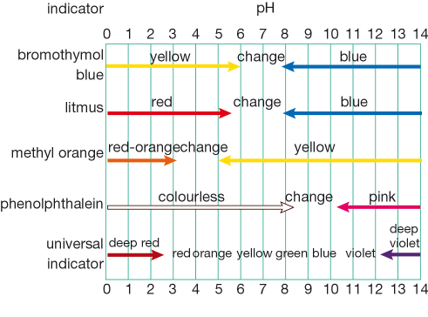

1. The pH of an acidic solution is 4. What colour would you expect the solution to be if tested with **universal indicator?**

1. An unknown solution was tested with different indicators to determine its pH. The results of these tests are shown in the table below:

|  |  |
| --- | --- |
| Indicator | Result colour |
| bromothymol blue | yellow |
| litmus | red |
| methyl orange | yellow |

Using the table AND the diagram above, what is the most likely pH level (or range of pH levels) for this solution?

1. The pH of a swimming pool always needs to be between 7.4 and 7.6. Is this pH range **acidic, neutral** or **alkaline**?

**Question 29 (3 marks)**

**Examine** the food chain shown below.

*water weed → tadpole → moorhen → swamp harrier*

For this food chain, **identify** the:

a producer

b herbivore

c third order consumer

**Question 30 (2 marks)**

Compare how matter and energy move through an ecosystem.

**Question 31 (2 marks)**

Explain why decomposers are vitally important in a sustainable ecosystem.

**Question 32 (3 marks)**

**Recall** the following electricity concepts by writing the correct term as described in the adjacent box.

|  |  |
| --- | --- |
| **TERM** | **DESCRIPTION** |
|  | A measure of how difficult it is for the charged particles in an electric circuit to move |
|  | The flow of electrical charge through a circuit |
|  | The difference in electrical potential energy carried by charged particles at different points in a circuit |

**Question 33 (3 marks)**

Thermos flasks like the one pictured below are designed to keep hot substances hot and cold substances cold. Careful choice of materials and clever design make this possible.

Plastic stopper:

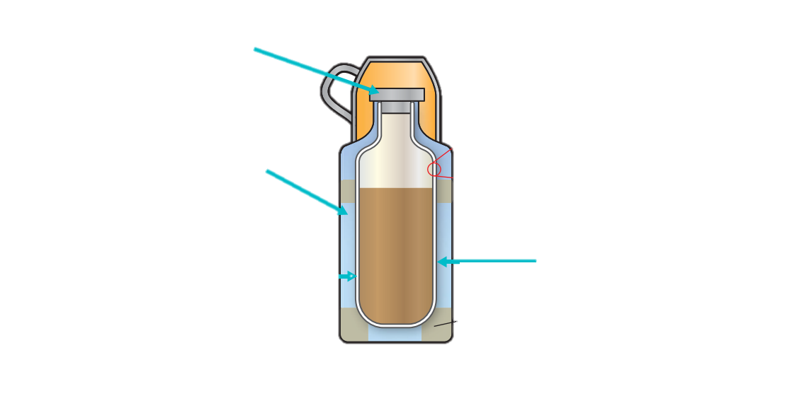

Glass walls:

Vacuum between the walls:

Next to each label in the picture above, **explain** how each choice of material helps to make a thermos flask effective.

**Question 34 (2 marks)**

When two or more globes are connected in a circuit, two different types of connection are possible – parallel and series.

**List** two advantages that the parallel circuit will have over the series circuit.



**END OF EXAM**

Please go back and check your work /

complete any unanswered questions.